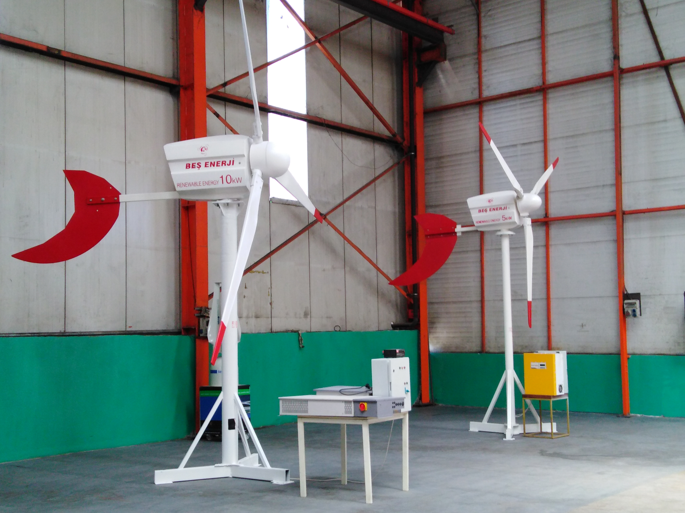 | BEŞ ELEKTRİK ENERJİ MAKİNE A.Ş.  (TURKEY)
Gayrettepe Mah.Yıldız Posta Caddesi Akın Sitesi 8/13 Ofis:5
Gayrettepe Mah./İstanbul/Beşiktaş

www.5enerji.com.tr
Email: cetinakcen@gmail.com55sda
Tel: + 90 546 650 21 95
Tel: + 90 535 020 70 59



Model | 5E-WT3-K/N | 5E-WT5-K/N | 5E-WT10-K/N
Orientation | Upwind | Upwind | Upwind
Rated Output | 3kw | 5kW | 10kW
Peak Output | 4kw | 6,5kW | 11,5kW
Output Voltage (V) | 12-24-220-380(Optional) | 24-48-220-380V(Optional) | 24-48-220-380V(Optional)
Generator Type | Synchronous Direct Drive | Synchronous Direct Drive | Synchronous Direct Drive
Applications | Off/On Grid Connection | Off/On Grid Connection | Off/On Grid Connection
Controller Type | PLC | PLC | PLC
Overspeed Protection | Blade Tip Brakes with Pitch Control | Blade Tip Brakes with Pitch Control | Blade Tip Brakes with Pitch Control
Blade Material | Carbonfiber | Carbonfiber | Carbonfiber
Number of Blades | 3 | 3 | 3
Rotor Diameter (m) | 2,7 | 3,5 | 6
Swept Area (m²) | 5,7 | 9,6 | 30,5
Windspeed (m/s)
Rated | 13 | 13 | 13
Cut-in | 3 | 3 | 3
Cut-out | 18 | 18 | 18
Governing
Survival | Pitch Control Max. 23 m/sec | Pitch Control Max. 23 m/sec | Pitch Control Max. 23 m/sec
Head Weight (kg) | 75 | 150 | 300
Tower Type | Steel | Steel | Steel
Tower Height (m) | 12-18 | 12-18 | 12-18
Product Life (years) | 25 | 25 | 25
Warranty (years) | 2 | 2 | 2
Units sold | 3 | 15 | 20
On the market since | 5 | 5 | 5
Price | Contact 5 Energy | Contact 5 Energy | Contact 5 Energy
Certificate | TSE-61400 | TSE-61400 | TSE-61400

